NSC 4319 Test 1 Review
Chapter 1
Pin the dendrites in the picture below
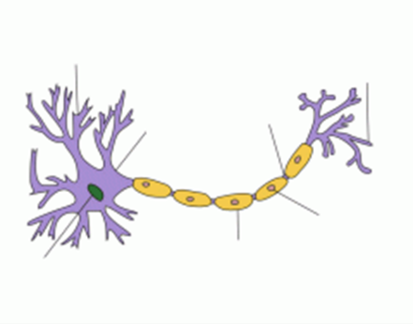
Which of the neurons below is a multipolar neuron?
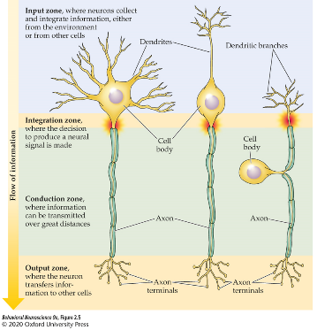
Which type(s) of glial cells can produce myelin? Oligodendrocytes and Schwann cells
Cranial nerve 9 is the _______ nerve. It controls the muscles of the throat. Glossopharyngeal
Motor information is carried through the _________ of a spinal nerve. Ventral root
The Thalamus is part of which MAJOR brain division? Forebrain
Draw the 3 primary shapes of neurons. Label the input and output zones
Chapter 2
At rest ________ is the only ion more concentrated in the intracellular fluid instead of the extracellular fluid. Potassium
_______ is the point at which electrostatic pressure and diffusion driving ion movement are equal equilibrium
the threshold of activation is the point at which __________ open voltage-gated sodium channels
Potassium is attracted to ________ charged environments negatively
Concentrations of which ions are included in the Goldman equation for equilibrium? potassium, sodium, and chloride
Describe what the intracellular and extracellular fluids look like at rest. Where are ions concentrated? What is the status of ion channels? what is the charge difference? sodium, calcium, and chloride more concentrated in the extracellular fluid. Potassium more concentrated in the intracellular fluid. voltage gated channels are closed. Potassium leak channels open. inside more negative than outside
During the depolarization phase of an action potential, which force(s) drive movement of sodium across the cell membrane? electrostatic pressure and diffusion
Chapter 3
Describe 3 possible symptoms of multiple sclerosis and how damage to the nervous system is related.
What happens to myelin during a relapse for an individual with multiple sclerosis?
The immune system attacks and destroys myelin
What is the direction of the early current (after depolarization using voltage clamp). inward
briefly describe how the voltage clamp technique works
the voltage clamps allows a researcher to set the membrane potential to a specific “command” value. A recording electrode records the membrane potential of the axon. If the membrane potential is different than the command potential, a current passing electrode will apply current to the axon until the command value is reached. The applied current is recorded and analyzed.
What are the two mechanisms through which conduction velocity can be increased?
Adding myelin and increasing axon diameter
The action potential primarily moves in one direction down the axon due to: refractory periods of voltage gated sodium channels
Chapter 5
__________ allow ions and other substances to flow directly from one neuron to another at electrical synapses. Connexons
_______ receptors allow for "fast" transmission whereas activation of _________ receptors is considered "slow" transmission. Ionotropic; metabotropic
Calcium binds to ________ on vesicles to initiate fusion with the presynaptic membrane. Synaptotagmin
During endocytosis ____________ disconnects a budding vesicle from the presynaptic membrane. Dynamin
List 3 characteristics of postsynaptic potentials that differ from action potentials. occur in dendrites/cell body, transmission between neurons, longer lasting, graded, passive spread

